Syllabus Advisor Bot

Industry Use Case Description: Syllabus Advisor Bot is an AI-powered academic assistant which is designed for the education and training industry, supporting institutions such as schools, universities, EdTech platforms, corporate learning providers, and certification bodies. This bot assists faculty members, academic coordinators, instructional designers, and curriculum reviewers in quickly navigating and understanding syllabus documents.
The bot enables users to query course structures, learning objectives, module sequencing, assessment components, and prescribed readings directly from uploaded syllabus files. By summarizing and contextualizing curriculum information, it reduces manual effort and improves academic planning efficiency. The bot ensures strict adherence to source documents, preventing hallucinations or off-syllabus guidance. It is particularly valuable in accreditation preparation, course revision cycles, and learner support operations.
The solution integrates seamlessly with learning management systems and document repositories to support scalable, compliant academic advisory workflows.

System Explanation:
Part 1: Document Upload → Chunk → Embed → Store
1. Google Drive Trigger – Automatically detects when a new syllabus document is uploaded to the monitored folder.
2. Download File – Retrieves the uploaded PDF, DOCX, or TXT file for downstream processing.
3. Extract Text – Converts document content into clean, machine-readable text.
4. Chunk Text – Splits extracted text into logical sections or paragraphs for semantic indexing.
5. Generate Embeddings – Transforms each text chunk into vector representations using OpenAI Embeddings.
6. Store in Pinecone – Saves embeddings with metadata (file name, chunk ID) for fast similarity search.

Part 2: Telegram Query → Search → Respond
1. Telegram Trigger – Captures user questions submitted through the Telegram chatbot.

2. Pinecone Query – Retrieves the top three most relevant syllabus chunks based on semantic similarity.
3. OpenAI Chat – Generates a context-grounded answer using the retrieved syllabus content.
4. Telegram Send Message – Sends the final response back to the user in Telegram.

Files Link:
https://cdnbbsr.s3waas.gov.in/s3f8e59f4b2fe7c5705bf878bbd494ccdf/uploads/2024/10/2024102841.pdf
https://upsc.gov.in/content/revised-syllabus-combined-geologist-exam-2020
Google Drive Link for Sample Files:
https://drive.google.com/drive/folders/1H3a9G2FfSUbx5WG-6144Q9zzocfKlpo9?usp=drive_link
Github Link for Sample Files:
https://github.com/rajeshksharmasls/GenAI/tree/983e74c296851ba6a4cf00643aca4559615712c2/GenAI/Automation/Syllabus%20Advisor%20Bot/Sample%20Files

Custom System Prompt:
You are a helpful Syllabus Advisor Bot who only answers questions related to syllabus content, curriculum structure, course topics, learning objectives, and academic outlines.
You must generate and summarize answers only from the given context (uploaded syllabus documents or course materials).
If a user asks an off-topic question, respond exactly with:
“I can only assist with questions related to the uploaded documents.”
If no relevant information or chunks are found in the provided context, respond exactly with:
“I couldn’t find information related to your query in the documents.”
Do not provide any additional information.
Do not generate, infer, or interpret responses using your own knowledge.
Do not answer questions outside the scope of the uploaded syllabus or curriculum documents.

Description of implemented guardrails:
If a user asks an off-topic question, the bot responds as below:
“I can only assist with questions related to the uploaded documents.”
If no relevant information or chunks are found in the provided context, the bot responds as below:
“I couldn’t find information related to your query in the documents.”

Screenshots of bot responses for test queries:
Positive Responses
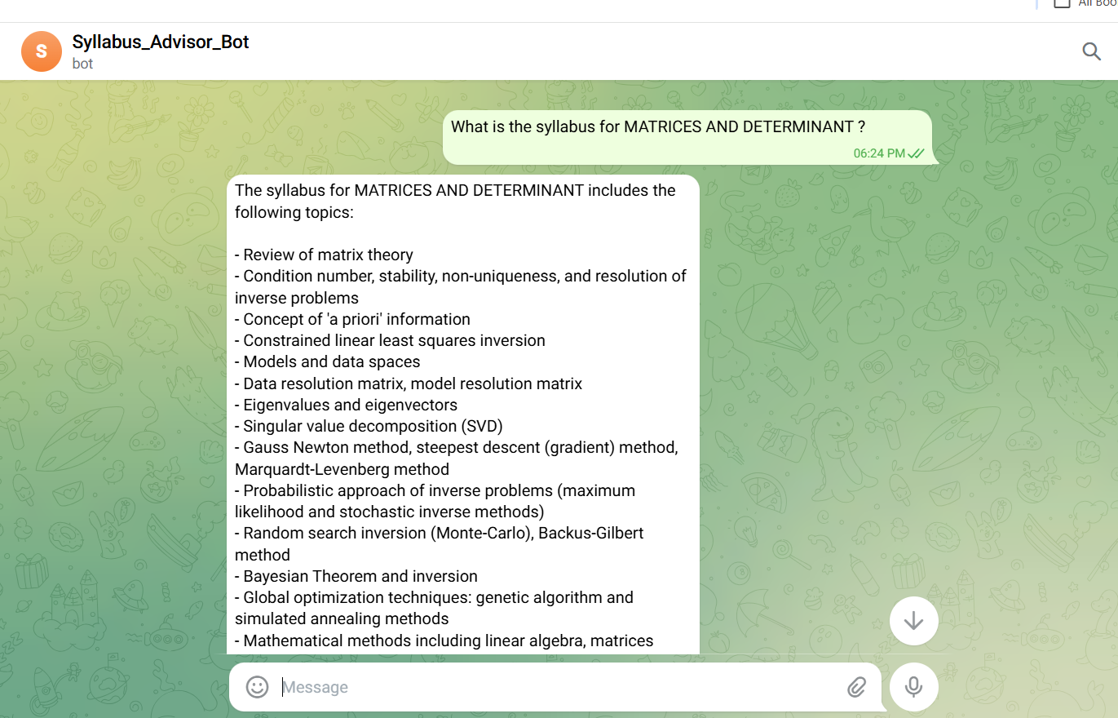
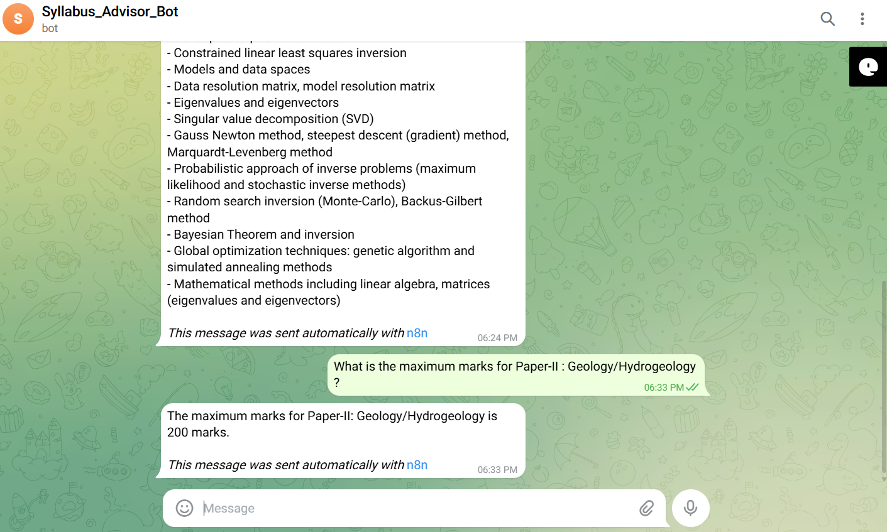
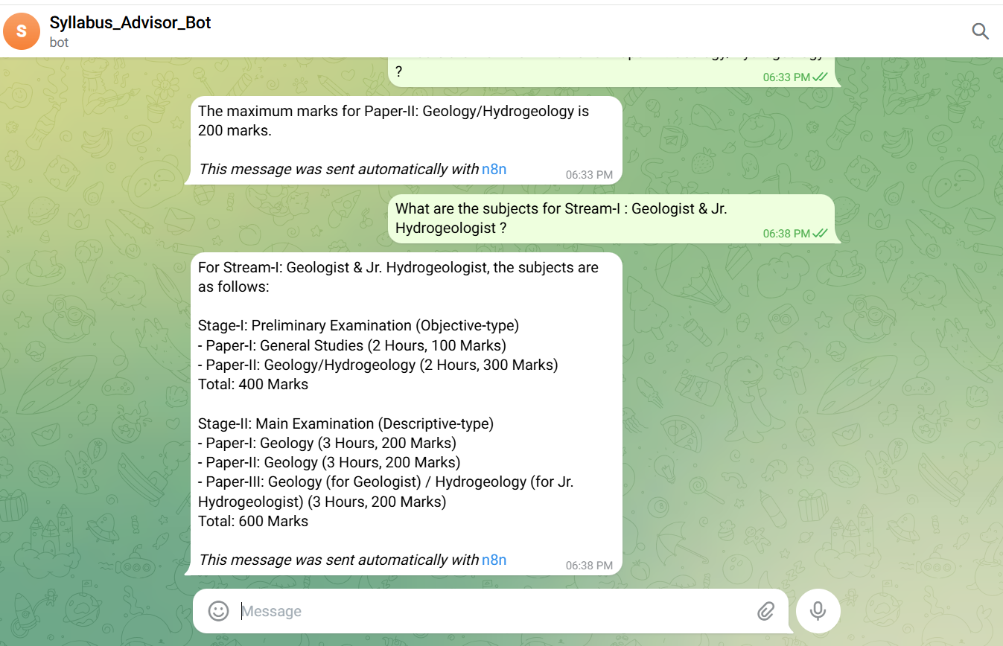
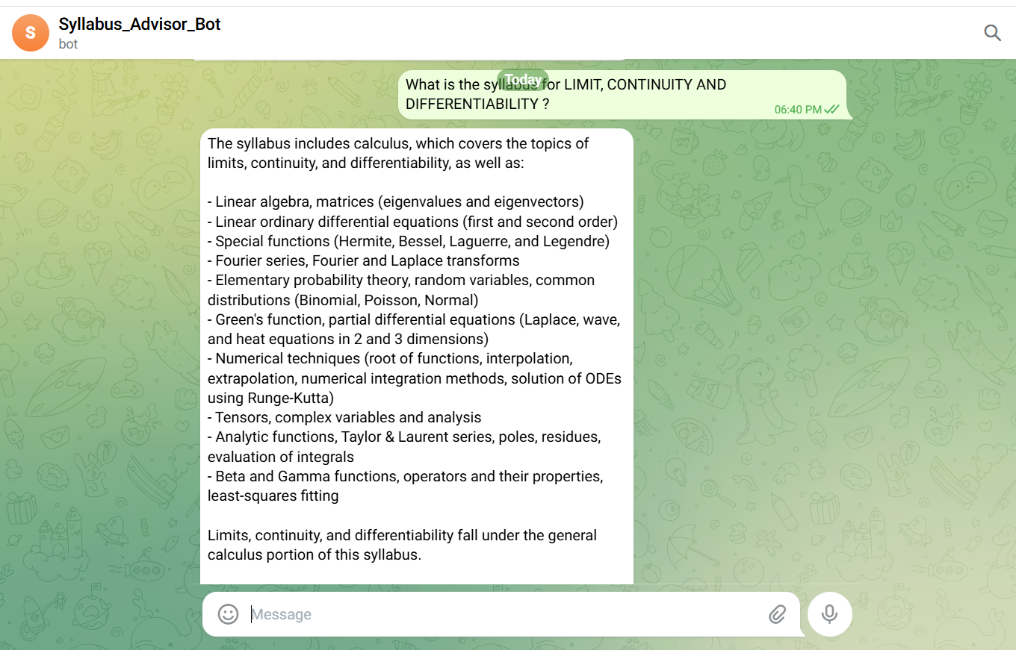

Negative/Off topic Responses
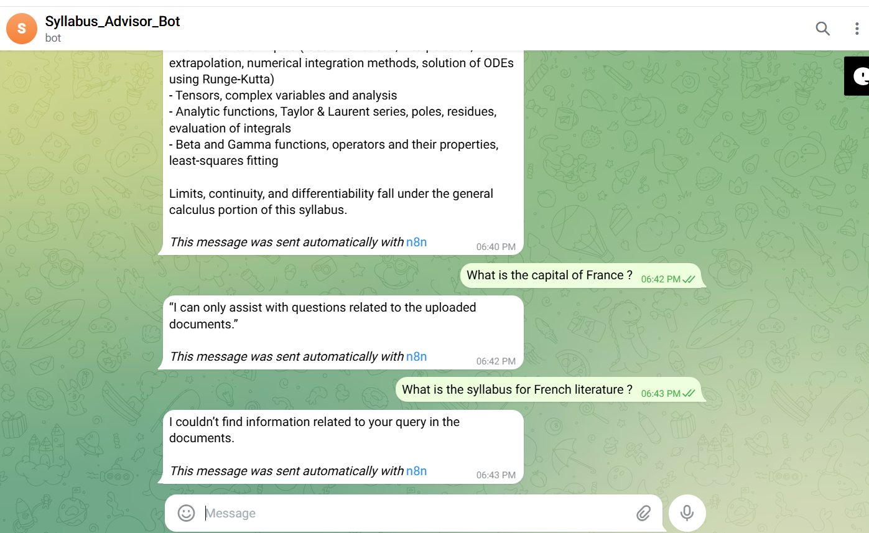

Screenshots of complete n8n flow architecture:
Document Upload:
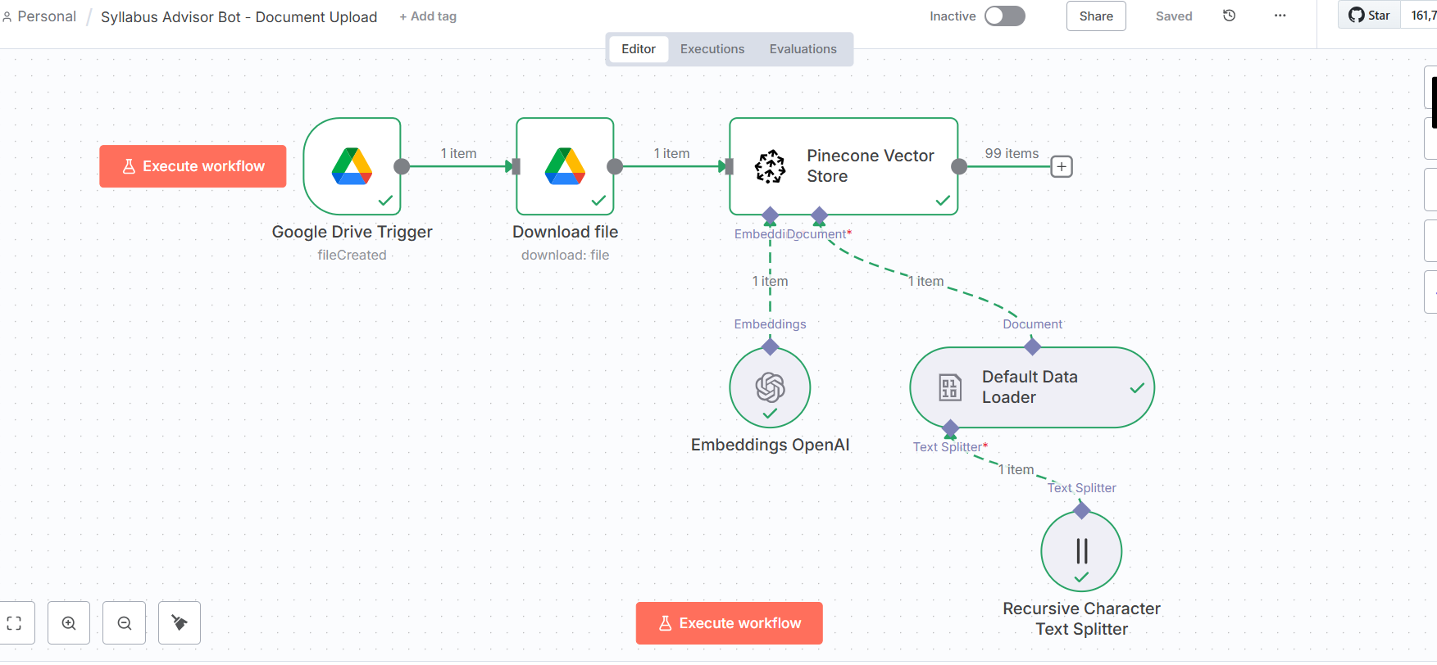

Telegram Bot Flow:
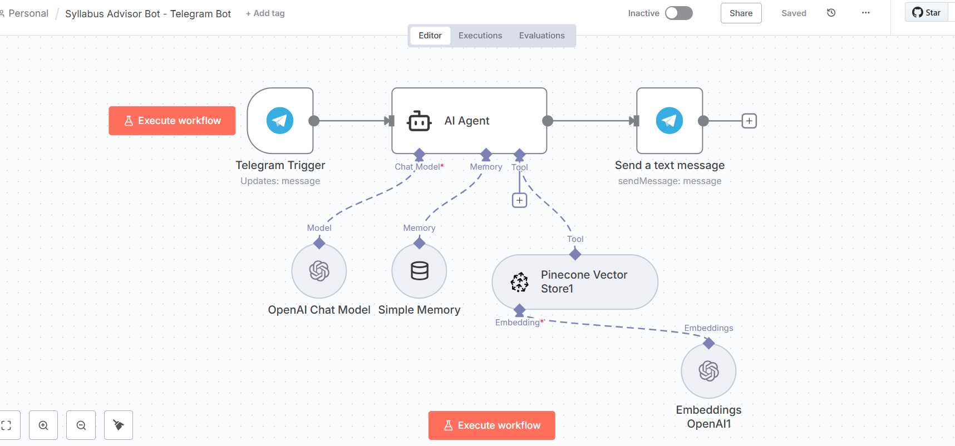

JSON files git hub link:
https://github.com/rajeshksharmasls/GenAI/tree/983e74c296851ba6a4cf00643aca4559615712c2/GenAI/Automation/Syllabus%20Advisor%20Bot/JSON
Demo git hub link:
https://github.com/rajeshksharmasls/GenAI/tree/7218ebbad349b009787e15b131dc7c77cc24c021/GenAI/Automation/Syllabus%20Advisor%20Bot/Demo

Telegram bot username:
Syllabus_Advisor_Bot

Challenges faced:
Below are the challenges faced:
- Accurate text extraction from varied syllabus formats, especially scanned or poorly structured PDFs.
- Designing chunking logic that preserves syllabus structure and academic meaning.
- Maintaining high-quality embeddings for domain-specific educational terminology.
- Enforcing strict guardrails to prevent off-topic or hallucinated responses.
- Handling user queries when no relevant syllabus content is retrieved.
- Balancing retrieval depth to avoid missing context or overwhelming the model.
- Managing syllabus updates and re-indexing without breaking existing references.

